CURRICULUM VITEA
OF
NORMAN ARRISON, B.Sc., M.Sc., Ph.D., P.Eng.
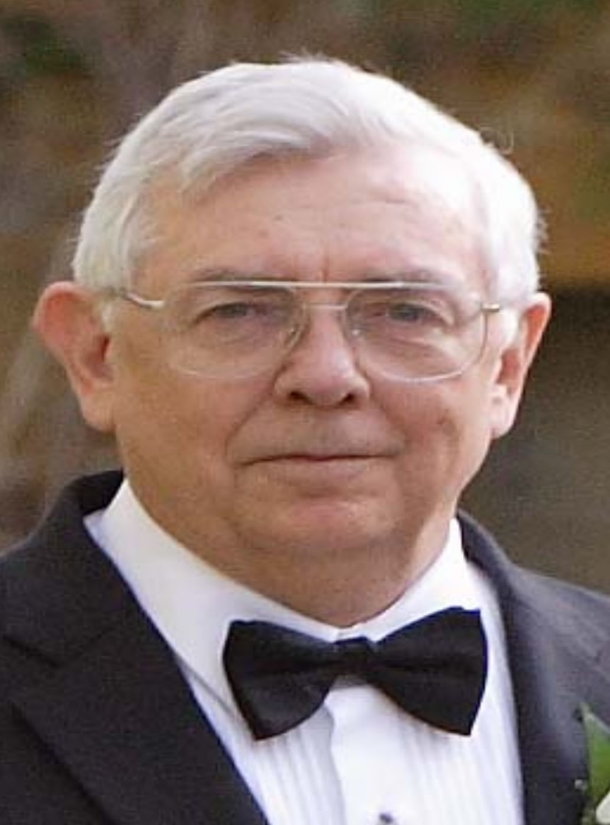

PERSONAL INFORMATION:

Name: Noman L. Arrison
Address: #457, 2750-55 Street N.W.
Edmonton, AB
T6L 7H5
Telephone: (780) 488-7359 Cell: (780) 221-7359
E-Mail: narrison@shaw.ca
Date of Birth: June 28, 1940
Nationality: Canadian
Marital Status: Widowed
Language: English

EDUCATION:

1963 – Bachelor of Science in Chemical Engineering / University of Alberta
1966 – Master of Science in Chemical Engineering / University of Alberta
1972 -- Doctor of Philosophy in Chemical Engineering / University of Calgary

AFFILIATIONS:

The Association of Professional Engineers of the Province of Ontario

The Association of Professional Engineers, Geologists and Geophysicists of Alberta

The Association of Professional Engineers and Geoscientists of the Province of Manitoba

Word Experience:

2015 – to present: Working on waste disposal plat in Condor Alberta

2012 – 2015: Working at Quinn Constrution Ltd. as Senior Engineer
on new SAGD and SAP methods for Alberta Oil Sands

2008 – to date: Worked on methane to methanol plants

2008 – to date: Worked on up-stream waste oil recovery and various
waste oil remediation systems.

2008 – to date: Worked on the development of anolyte to stop H₂S
insitu formation and ASS—210 H2S scavenger

2008 – to date: Worked on refineries for the production of diesel from
heavy oils and gas.

2002 – 2008: Worked on new biofuels technology converting lignin,
Hemicellulose, and cellulose into biofuels without
enzymes or yeasts.

1994 – 1998: Designed and demonstrated thermophilic plants to
convert animal and human waste into pathogen-free
fertilizer. This process is now used extensively in North
America.

1993 – 1998: worked on development of different types of cyclones
for varied applications. 1997 has patent pending for
various applications.

1992 – 2002: Worked as an international consultant in the
development of a new oil processor to convert waste
oil to diesel fuel and is a co-patent holder. This
process is now used in Poland, Spain, Korea and
Australia, and continues to spread to other countries.

1990 – 2008: WHMIS INC.
CEO and majority owner of the above company which
specializes in the following services:

- Workplace hazardous materials information system (W.H.M.I.S.)
- Emergency response plans
- Environmental management programs
- Environmental audit programs
- Waste management programs
- Environmental impact assessment
- Soil and groundwater remediation
- Used oil re-cycle and re-fining
- Greenhouse gas emissions audit programs
- Incinerator studies and applications
- Transportation of dangerous goods
Worked and helped develop specialized coatings for specific
industrial applications for the past three years for MAC
International. These products are now used extensively in S
Canada and are just beginning to gain acceptance in other parts
of the world.
Safety consultant for the Edmonton Catholic School Board

1990: Participated in HAZOP review of the ALPAC DRAFT Pulp and
Paper Mill at Athabasca, Alberta.

1988 to 1990: ARRISON CULSULTANTS LTD.
Research and technical director of L.S. Laser. The work
involved White Light technology for use in mining,
metallurgy, and other industrial applications. This new rock-
breaking technology uses high intensity light.

1986 – 1988: ALBERTA LASER INSTITUTE
CEO of the Alberta Laser Institute. Supervised the start-up of
the Institute, the purchasing of its primary lasers, the initial
research projects, and the personnel.

1979 – 1986: GLOBAL THERMOELECTRIC POWER SYSTEMS LTD.
Director of Research and in charge of government liaison
and lobbying.

1972 – 1979: ATOMIC ENERGY OF CANADA
Design Officer in charge of safety systems for the 600 MW
CANDU Nuclear Reactor. Responsible for making certain the
public was not exposed to any toxic or radioactive
discharges from the 600 MW reactors. Responsibilities for
the 600 MW reactors led Dr. Arrison to be one of the first
design engineers in Canada to use fault trees and risk
assessment analysis.

1967 -- 1972: UNIVERSITY OF CALGARY
Completed Ph.D. Also during this time did a consulting job
For Canadian Western Natural Gas and operated a small
cosmetics manufacturing company.

1966 – 1967: IBM (INTERNATIONAL BUSINESS MACHINES)
Worked on Software for:
- The Inter-provincial Pipe-line
- Stelco Stell extruder
- Hinton pulp and paper mill

1964 – 1966: UNIVERSITY OF ALBERTA
Completing Master’s Degree

1963 – 1964: POLYSAR
In charge of sewage systems. Responsibilities included
monitoring cooling and sewer streams that discharged into
the St. Clair River.

SPECIALIZED EXPERIENCE:

Dr. Arrison was a member of the Science Council of Canada for two terms. Once appointed by Prime Minister Pierre Trudeau and once appointed by Prime Minister Brian Mulroney.

PUBLISHED PAPERS:

EXTENSIVE – SET FORTH IN LIST OF PUBLICATIONS ATTACHED.

TICKETS HELD FOR OIL FIELD ACCESS: EXPIRES:

- H₂S Alive given at ENFORM 13/03/2016
- Detection and Control given at ENFORM 07/02/2017
- Construction Safety Training System ---------------
- TDG 04/10/2016
- WHMIS 04/10/2016
- First Aid 31/01/2017
- Power Line Safety (Cenovus) 04/02/2017
- General EH&S Orientation (Cenovus) 04/02/2017
- Benzene Awareness (Cenovus) ---------
- Ground Distrubance Orientation (Encana) ----------
- Safety Oreientation for Service Providers (Encana) ----------

NORMAN L. ARRISON, Ph.D., P.Eng.
LIST OF PUBLICATIONS AND PRESENTATIONS
Publications and Presentations 1
PUBLICATIONS and PRESENTATIONS

PUBLICATIONS

1 . "The Design of a Special Purpose Non-Linear Controller'', M.Sc. Thesis, University of Alberta, October, 1965.
2. "Butyl Acetate System", Ph.D. Thesis, University of Calgary, June, 1973.
3. "An Experiment to Determine Whether Zirconium Metal and Organic Coolant React Chemically at Elevated Temperatures", N. L. Arrison, WNRE-151, 1974.
4. "Forced Convection Heat Transfer to WR-1 'A' Circuit Coolant in Tubular and Annular Geometries", R. B. Jeffries, N. L. Arrison, T. E. Macdonald, R. K.
5. Armstrong, C. K. McCallum, J. D. Rawlings and D. R. Greig, WNRE-164, 1975.
6. "Heat Transfer Cooling Conditions for Multi-Component Organic Liquid in Counter Current Concentric Tube Exchanger'', N. L. Arrison, et. al. , WNRE- 164, 1975.
7. "More Efficient Method of Regeneration for Sorption Separation Columns", N. L. Arrison and R. B. Jeffries, WNRE-238, 1975.
8. "Slowdown Experiments on the WNRE-RD-4A Loop with 40 Second Time Scale", N. L. Arrison, et. al., WNRE-278, 1976.
9. "Emergency Core Coolant (ECC) Experiments on the WNRE-RD-4A Loop," N. L. Arrison, et. al. , WNRE-279, 1976.
10. "Emergency Core Coolant (ECC) Experiments on the WNRE-RD-4A Loop with 40 Second Time Scale", N. L. Arrison, et. al. , WNRE-280, 1976.
11 . "RE-4A Emergency Core Coolant (ECC) Injection Configuration Experiments", N. L. Arrison, et. al. , WNRE-281 , 1976.
12. "Feasibility Study on the Precision of Measuring Two-Phase Flow with a Modified Pitot Tube", N. L. Arrison, et. al. , WNRE-282, 1976 Publications and Presentations 2
13. "RD-4A Two-Phase, Slowdown Pump Tests: Vol. I", N. L. Arrison, et. al., WNRE-283, 1976.
14. "RD-4A Two Phase, Slowdown Pump Tests: Vol. II", N. L. Arrison, et. al., WNRE-284. 1976.
15. "RD-4A Slowdown with 15 Seconds of Full Power'', N. L. Arrison, et. al., ·wNRE-285, 1976.
16. "Slowdown Experiments on the WNRE-RD 4A Loop", N. L. Arrison, et. Al., WNRE-250, 1976.
17. "Comparison of Discharge Rates from a Pressurized Vessel for D20 and H20 at Saturated Conditions", N. L. Arrison, et. al. , WNRE-294, 1976.
18. "Centrifugal Pump Performance with Steady and Transient Steam-Water Flows", N. L. Arrison, et. al., paper presented at JUICE Meeting, Winfrith,
U. K., October 13, 1975.
19. "Subcooled Slowdown of Recirculating Pressurized Water Loops", N. L. Arrison, et. al. , paper presented at JUICE Meeting, Winfrith, U. K., October, 1975.
20. "Slowdown of a Recirculating Loop with Heat Addition", N. L. Arrison, et. al., I. Mech. E. , 1977, Pages 77-82.
21. "Polyethylene Plastic Wastes", Dr. Norman L. Arrison, A Report for NovaHusky Research Corporation, Calgary Alberta, January, 1993.
22. "Plastics Waste" , Dr. Norman L. Arrison, A Report for the Bituminous Material Chair of the University of Calgary, September, 1999.
23. U.S. Patent Application 09/539,704-lnvention- Apparatus and Process for Separating Fluids and Particles, U.S. Filing Date- March 31 ,2000.
24. PCT Patent Application PCT/CA00/00449, Invention- "Horizontal Distillation Apparatus and Method"
25. Canadian Patent Application 2,225,635, lnvention-Apparatus and Process for Reclaiming Fuel Oil from Waste Oil, Filing Date - August 1, 1997.
26. U.S. Provisional Patent Application 60/273,625, Invention - Auder Cleaning of Solids Contaminated With Volatile Liquids, U.S. Filing Date - March 7, 2001

Publications and Presentations 3

27. U.S. Provisional Patent Application 60/234, 192, Invention - "Method and Apparatus for Producing Potable Drinking Water -From Air", U.S. Filing Date - September 20, 2000
28. Lite Breaker" demonstration presented to HONG-IK Engineering Consultants Co., Ltd. of Seoul, Korea, Graymont Western Canada Inc., and other Alberta Investors at quarry in Blairmore, Alberta, May 8-11 , 2000.
29. Invention - Method and Apparatus for Fracturing Brittle Materials by Thermal Stressing; Canadian Patent Application 2,310,883; Filed June 6, 2000
30. Invention - Arc Lamp and Method of Use U.S. Provisional Patent Application No. 60/319,879; Filed January 17, 2003
31 . DRILLING MUD REMEDIATION, U.S. Patent Docket No. 53114.1
32. U.S. Patent Application US 2011/0186462 A1, Microcidal Composition
33. U.S. Patent Application US 2012/0202721 A1, Electrolyzed Water – Amine Compositions and Methods of Use
34. U.S. Patent US944766782, Steam Inert System for Quinn Construction Ltd. January 2014.
35. U.S. Patent Application US 2014/127, 196 Catalytic Biomass Conversion 36. Canadian Patent 2, 766,664 Amines Compositions and Methods of Use, 2016

PRESENTATION

1. "The Design of a Special Purpose Non-Linear Controller'', presented at the 16th Canadian Chemical Engineering Conference, Windsor, Ontario, 1967.
2. "Analysis of the Manipulated Variable in Stochastic Processes", presented at the 16th Canadian Chemical Engineering Conference, Windsor, Ontario, 1967.
3. "Heat Transfer Limitations for a Multi Component Organic Liquid in a Tubular Geometry", presented at the 24th Canadian Chemical Engineering Conference, Ottawa, Ontario, 197 4 (with R. B. Jeffries).
4. "Forced Convection Heat Transfer to a Multi Component Organic Liquid in Various Geometries", presented at the 24th Canadian Chemical Engineering Conference, Ottawa, Ontario, 1974 (with R. B. Jeffries).
5. "Heat Transfer Properties of OCR·Coolant", presentation to the University of Alberta, March, 197 4.
6. "Centrifugal Pump Performance with Steady and Transient Steam-Water Flows", presented at JUICE Meeting, Winfrith, U. K,. October, 1975 (with W. T. Hancox).
7. "Subcooled Slowdown of a Recirculating Pressurized Water Loop", presented at JUICE Meeting, Winfrith, U. K., October, 1975 (with W. T. Hancox).
8. "Slowdown of a Recirculating Loop with Heat Addition", presented at McMacter University, Hamilton, Ontario, 1977 (with W. T. Hancox, M. T. Sulatisky, and S. Banerjee)
9. Numerous presentations to the Atomic Energy Control Board on behalf of Atomic Energy of Canada Ltd. in Ottawa and Montreal. Presentations were given under the supervision of G. Brooks, Vice President, and B. Renshaw, Vice President of AECL.
10. Chairman, Session 4, The Combustion Institute (Canadian Section), Spring Technical Meeting, Carleton University, Ottawa, Ontario, May 14-15, 1981 .
11 . "Thermoelectric Power Supplies for Reliable Commercial Microwave Systems at Low Cost", presented at 30th Power Sources Symposium, The Deauville Hotel and Motor Inn, Atlantic City, New Jersey, U. S. A. , June 7-10, 1982 (with L. S. Wilson).
12. "Carving a Technological Niche for Canadian Industry", presented at The Canadian Institute of Strategic Studies Fall Seminar, 1986. "Tactics and Technology", Ontario Hydro Centre Auditorium, Toronto, Ontario, November 7-8, 1986.
13. "Surface Treatment Using Powerful White Light Sources", presented at the World Materials Congress, September 24, 1988, at McCormick Place, Chicago, Illinois, U. S. A. , (with D. M. Camm).
14. "Probable Accidental Discharges of Clorinated Organic Compounds from the Alberta-Pacific Forest Industries Inc. Pulp Mill into the Athabasca River." A Publications and Presentations 5 preliminary HAZOP Review of the Mill Safety Design. Presented to the ALPAC Scientific Review Panel, Athabasca, August, 1990.
15. "Safety and Evironmental Issues with Respect to Their Effect on the Automobile Recyclers of Alberta", presented to ·the Auto Recylers Association of Alberta, February, 1991 .
16. "Coal Beneficiation", presented to Chinese Delegation, Edmonton, Alberta, October 14, 1992 (with Dr. J. Visman).
17. "Coal Beneficiation and AutoMedium Cyclone Processes", presented to Polish Coal-mining Industry and Government Officials, Warsaw, Poland, November 1 and November 4, 1993.
18. "Coal Beneficiation and AutoMedium Cyclone Processes", presented to Polish Delegation from Konin Mines, Edmonton, Alberta, May 23-26, 1994.
19. "Coal Beneficiation and AutoMedium Cyclone Processes", presented to Czech Electrical, Utilities, Mining Companies, and Government officials, Prague, Czech, September 29-30, 1994.
20. "Lite-Breaker--Technology and Applications", presented to Canadian Mining Research Organization (CAMIRO) at Sheraton Hotel in Toronto, ON, June
28-29, 1996.
21 . "Specialized Industrial Coatings Presentation" to the company LUBON from Poznan, Poland, October, 1996
22. "Specialized Industrial Coatings Presentation" to the company Utopia Korea Ltd. in Seoul, Korea, May, 1996.
23. "Waste Lubrication Oil Reprocessor" presented to National Oil Recyclers Association Conference, San Diego, California, U.S.A., November 18, 1997.
24. "Reprocessing Technology for Waste Oil" presented to University of Maribar and Government of Slovenia in Maribar, Slovenia, October 18, 1999.
25. "Soil and Pond Cleaning Methods" presented to officials of Croatia and National Petroleum Association of Slovenia in Zagreb, Croatia, October 19, 1999 and in Ljubljana, Slovenia, October 20, 1999.
26. "Cleaning of sand and clay using jet pumps, centrifuges, and desorption though high temperature treatment, presented to CRNL.
27. Coal conversion to oil presented at M.l.T. in September, 2009 Publications and Presentations 6
28. Methane gas to diesel via Fischer-Tropsch Process Houston, Texas July, 2013
29. SAGO and SAP designs at Quinn Construction April, 2013.

